**Wireframe Document**

**ANALYZING AMAZON**

**SALES DATA**

**Author**

**Siddharth Bhat**

Homepage

As per the problem statement, we have divided analysis into three sections: -

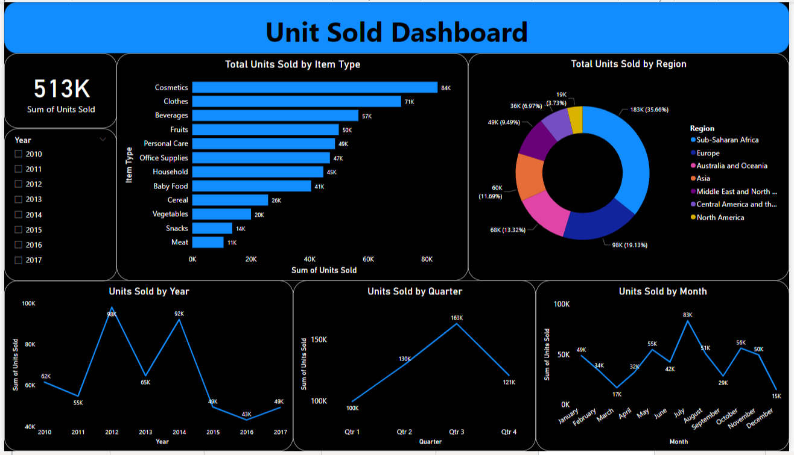**1.How much quantity sold of different types of Items on year wise, quarter wise, month wise and region wise**

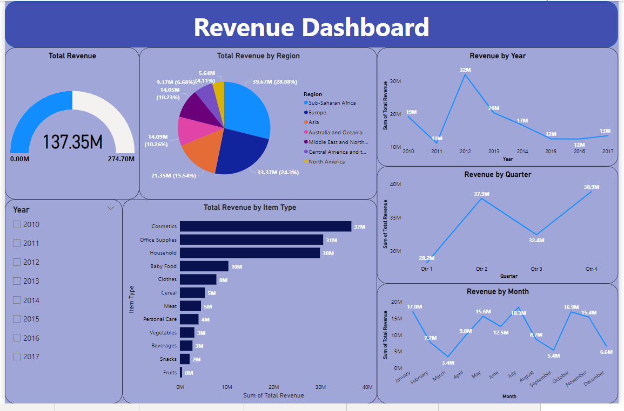**2.How much revenue generate of different types of Items on year wise, quarter wise, month wise and region wise**

**3.How much profit generate of different types of Items on year wise, quarter wise, month wise and region wise**

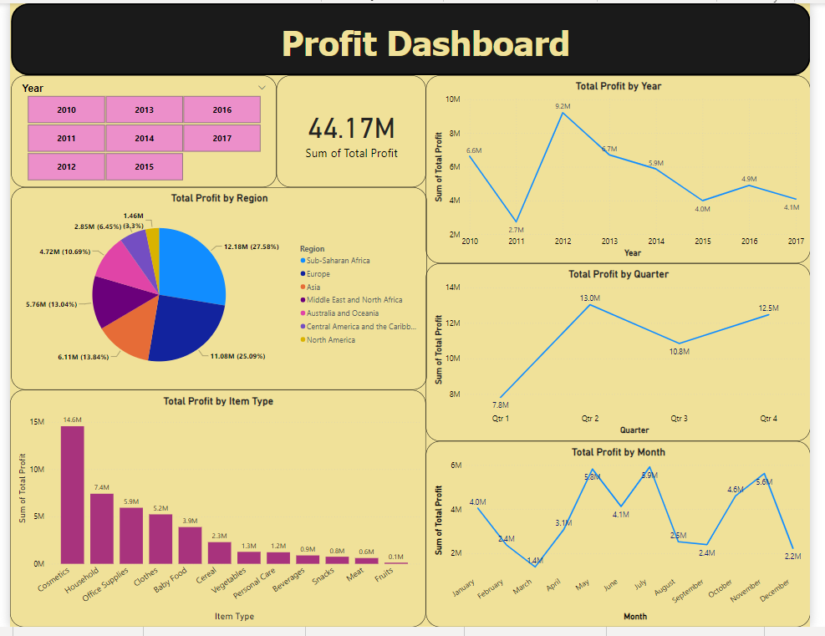

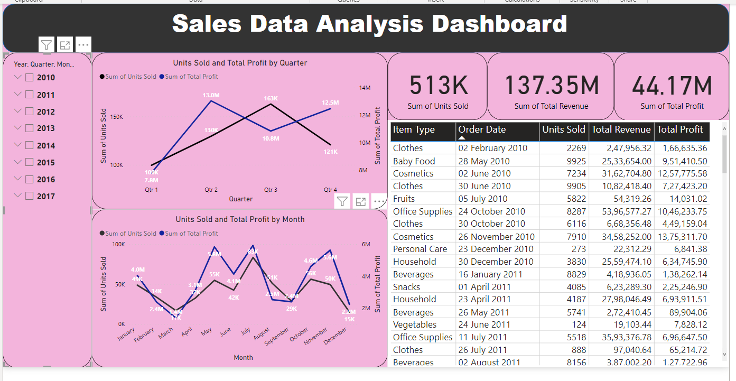**This is a final Dashboard of Sales Data Analysing**